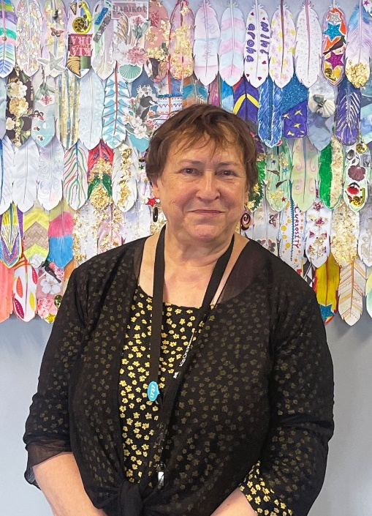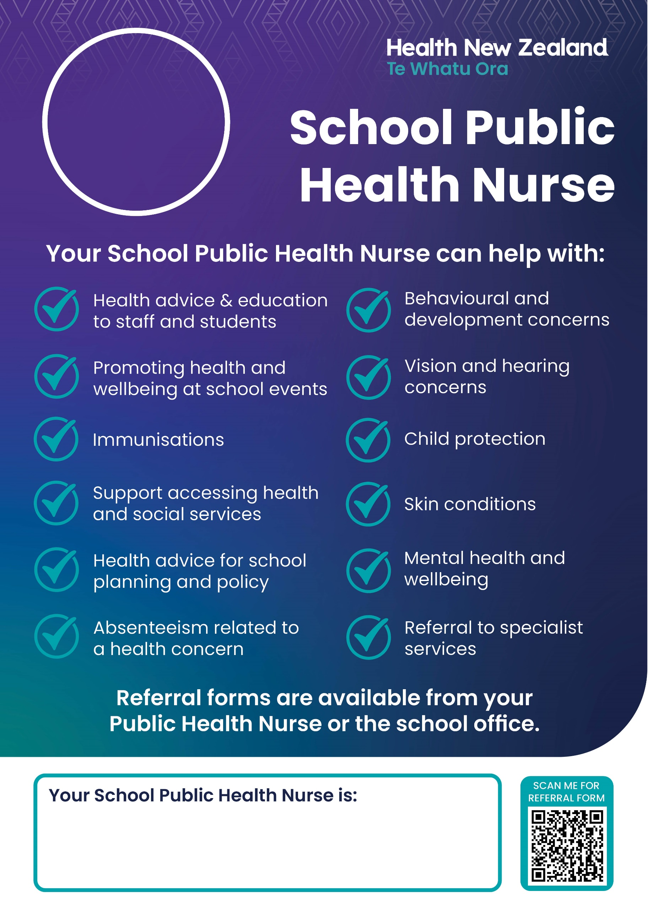

Phyllis Savage | M: 027 285 3486

E: Phyllis.Savage@huttvalleydhb.org.nz

My days are Tuesday, Wednesday and Thursday